Project SE

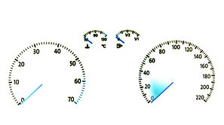Dashboard

**Group 6:**

Fábio Magalhães – A75030

Rui Carvalho – A76279

Index

Problem Statement 3

Market Study 4

Constraints 5

Technical Constraints 5

Functional Requirements 5

Non-Functional Requirements 5

Hardware Specifications 6

Software Specifications 6

System Overview 7

Events 7

Use Cases 8

State Chart 8

Sequence Diagram 9

System Stack 10

Software System Overview 10

Gantt Chart 11

Problem Statement

All recent automobiles have an on-board computer, that assist the driving and the maintenance of the vehicle. It has become an accessory more and more indispensable, however it is still very expensive for the masses. Yet possible to install on older vehicles, it brings mechanical complications, and great monetary cost.

The Project’s goal is to develop an efficient, plug-n-play, inexpensive, functionality full on-board computer for the most affordable vehicles. I will be perfect companion to every road trip.

The device should get data from the car onboard diagnostic (OBD), as well as get the road slope from the gyroscope and advise the driver by showing information to the user. The information shown must be customizable by the user through button input.

Market Study

There are few similar products in the market, since most care more with audio and video display than to monitor the car and advise the driver.

**X50 Plus OBD**

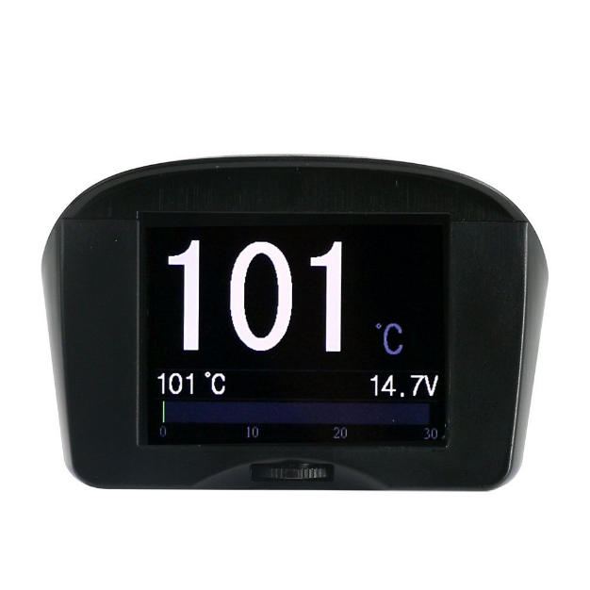 X50 Plus OBD mini car trip computer is a small car instrument with powerful functions, which is especially suitable for vehicles without a tachometer, an engine temperature gauge and fuel consumption display functions.

X50 Plus can also display and monitor vehicle battery voltage, generator charging voltage, offering vehicle over speed alarm, high engine temperature alarm and monitoring and other functions. It even can read vehicle data streams, scan engine fault codes and offer fault code clearing functions. Available at a reasonable price.

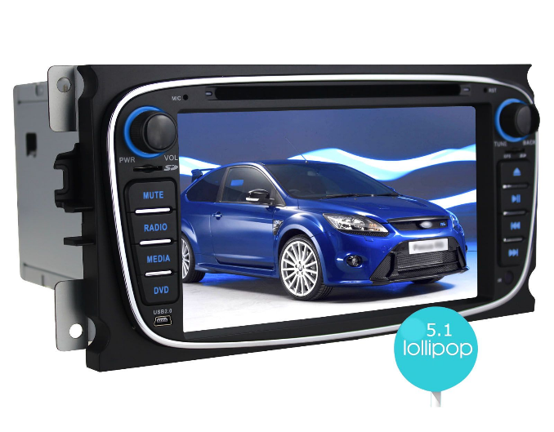 **JOYING**

Joying is a Professional high quality Android auto radio Head Unit In dash car GPS navigation supplier, which focus on entertainment while on trip, with network, audio, video, Bluetooth and GPS capability, instead of focusing on car monitor. Which inflates the price above a reasonable value.

­

Constraints

* Budget must be minimal.
* Project developed by a team of two.
* Pretty design

Technical Constraints

* Raspeberry Pi 3 Model B
* Buildroot
* Pthreads
* C/C++ programming language
* User Implemented Device Driver

Functional Requirements

* Get car information through OBD port
* Show data on screen
* Alert the user for malfunctions
* Calculate road slope
* Warn bad driver behaviour

Non-Functional Requirements

* Low Cost and low power.
* User-friendly interface.
* Plug’n’play
* Low latency.
* Soft Real-time

Hardware Specifications

* Raspberry Pi 3
  + BCM2837 Chip 64 bit ARMv8 Cortex A53 Quad Core
  + 1GB RAM
  + Wireless LAN
  + Bluetooth 4.1
  + 4 USB Ports
  + 40 GPIO Pins
  + HDMI Port
  + Ethernet Port
  + Micro SD Card Slot
* TFT with Touchscreen
  + ILI9488 Display Driver
  + 320x480 Resolution
  + Resistive Touchscreen
* OBD module with Bluetooth
  + ELM327
  + OBDII interface
* Accelerometer and Gyroscope
  + MPU-6050
  + Six Axis
  + I2C Communication
* Tactile Buttons

Software Specifications

* Embedded Linux
* C/C++ Language
* Buildroot

System Overview

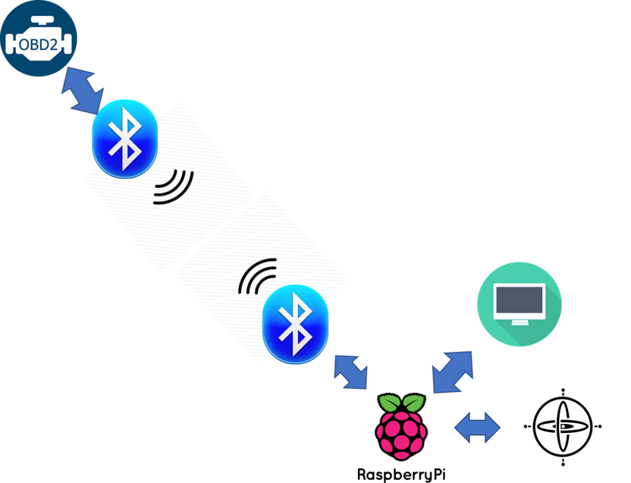

Events

|  |  |  |
| --- | --- | --- |
| Event | System Response | Source |
| On/Off | Turn System On/Off | User |
| Read OBD | Reads OBD data | Local Sys |
| Read Gyro | Reads gyroscope data | Local Sys |
| Display | Changes display | Local Sys |
| Button Click | Reads buttons states | User |

Use Cases

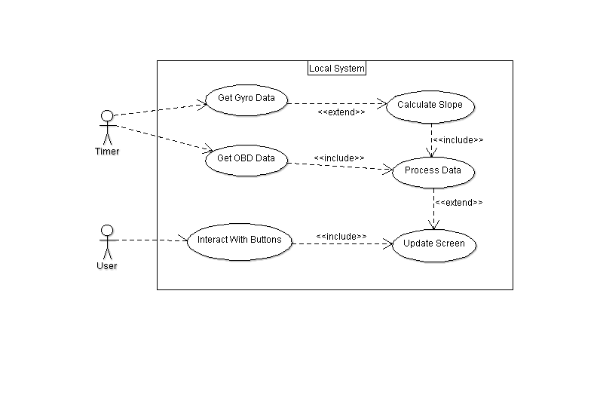

State Chart

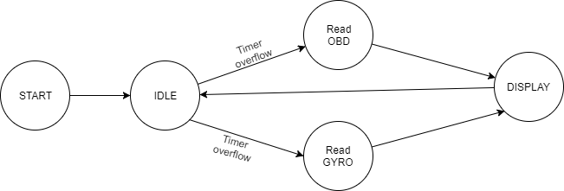

Local and Remote System

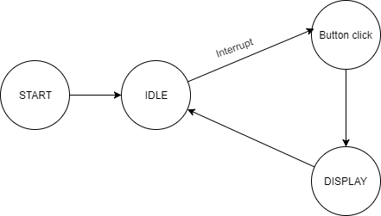

1User Interface

Sequence Diagram

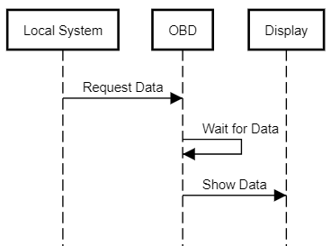

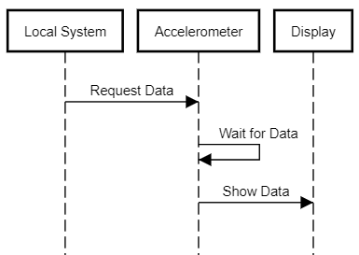

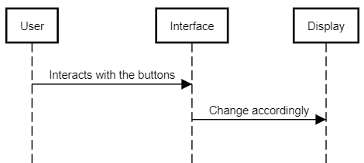

System Stack

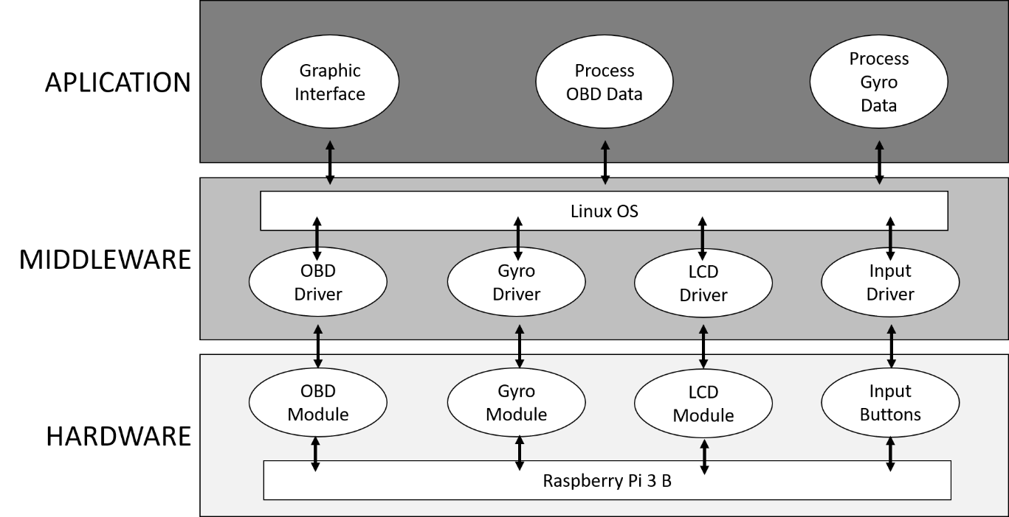

Software System Overview

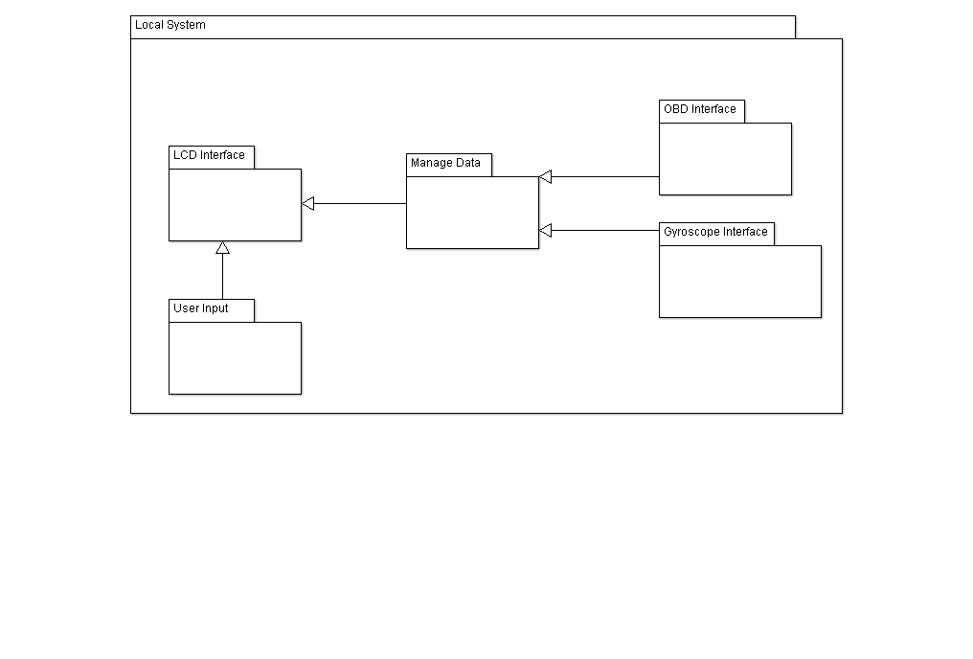

Gantt Chart

|  |  |
| --- | --- |
|  | Fábio Magalhães |
|  | Rui Carvalho |

